//LP3 Group C Assignment 4

//Cedrick Andrade COBA006

//SPDX-License-Identifier: MIT

pragma solidity ^0.6;

contract Student_management

{

    struct Student

    {

        int stud_id;

        string name;

        string department;

    }

    Student[] Students;

    function add_stud(int stud_id, string memory name, string memory department) public

    {

        Student memory stud = Student(stud_id,name,department);

        Students.push(stud);

}

    function getStudent(int stud_id) public view returns(string memory, string memory)

    {

        for (uint i=0; i<Students.length; i++)

        {

            Student memory stud = Students[i];

            if(stud.stud_id==stud_id)

            {

                return(stud.name,stud.department);

            }

        }

        return("Not Found", "Not Found");

    }

}

**Deploying Contract:**

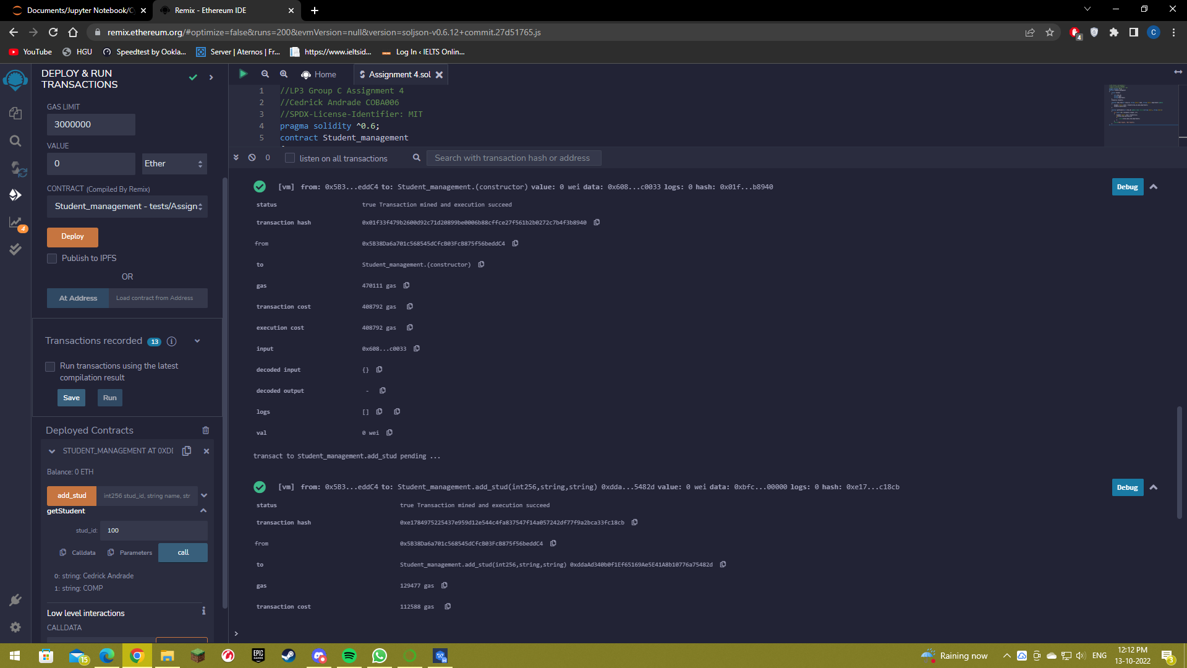

**Adding Student:**

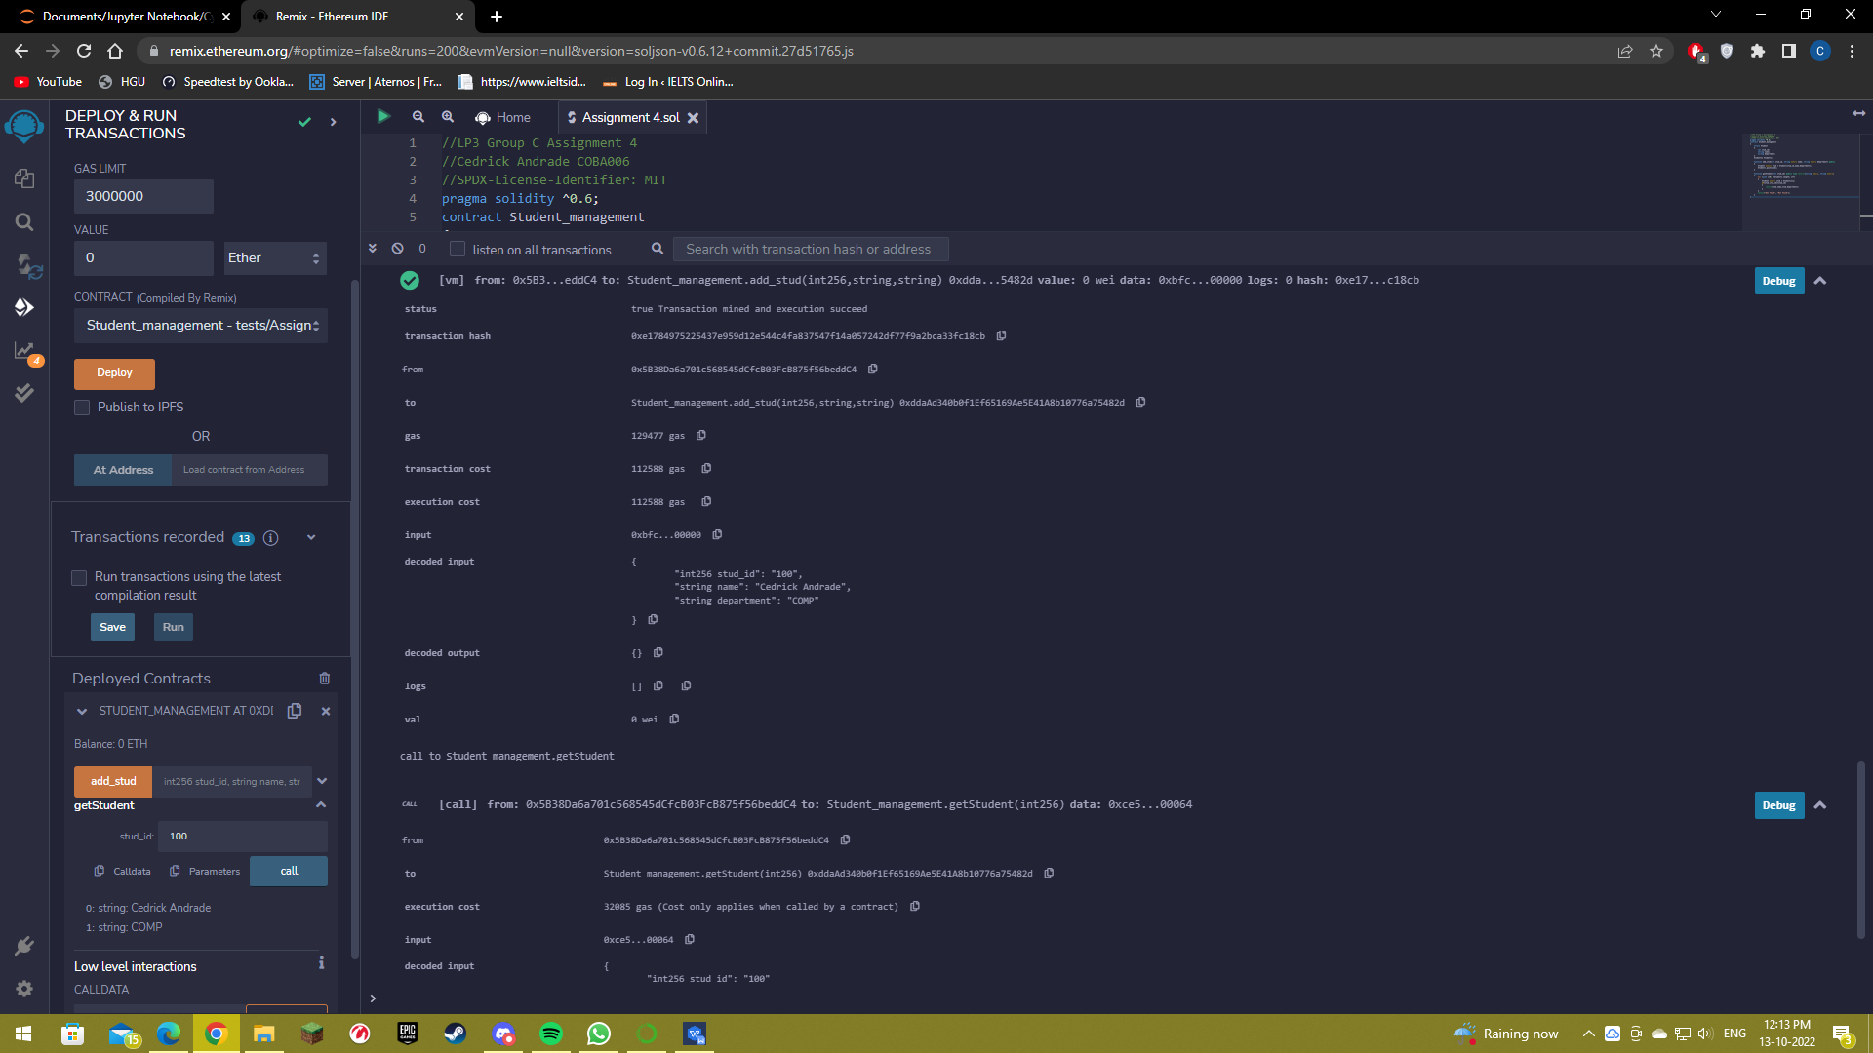

**Calling Student via ID:**

